ARTIFICIAL INTELLIGENCE IN HEALTHCARE
1) V. Sravan Reddy 2) Rakesh Kalshetty
Department of CSE (Cyber Security) Department of CSE (AI and ML)
Ramaiah Institute of Technology Ramaiah Institute of Technology
Bangalore, Karnataka, India Bangalore, Karnataka, India
sravanreddyv.work@gmail.com rakeshk.work@gmail.com

Abstract—In this paper, the study highlights and discusses the various modern applications of Artificial Intelligence, Machine Learning etc., in the healthcare sector. Today AI is revolutionising, strengthening healthcare through various technologies which can predict, grasp and act. The study mainly focuses on areas of AI-powered healthcare particularly in the fields such as Cardiology, Dermatology, oncology, pharmacy, Covid-19, speech recognition, for administration etc. The technologies like AI, machine learning, deep learning, neural network models have assisted doctors in diagnosing patients quickly, thus producing highly accurate results. Deep learning is mainly used in recognition of cancerous lesions in radiology images. Natural language processing helps in creating and understanding clinical documentation of patients. Patients’ medical data is also analysed by Artificial intelligence, which helps the physician in assisting the patients to improve their quality of life. Surgical robots used by surgeons to make minimal incisions, stitch wounds. Robots are given AI based brains, so image recognition is done by RPA (robotic process automation). Physical robots are nowadays used for various activities in hospitals like delivering supplies etc. Few startups are developing AI derived image interpretation algorithms. AI in healthcare is responsible for lack of job impact.

Introduction:
Artificial intelligence in healthcare is used to describe the use of machine learning algorithms and software or Artificial intelligence to copy human cognition in the analysing, presenting, and understanding of complex medical and health care data. The main objective is to replicate the human capabilities by providing new ways in diagnosing, treating, or preventing diseases. AI uses the computer algorithms to arrive at approximate conclusions based on input data.
In practice AI programs are applied in different healthcare areas such a diagnosis, treatment protocol development, drug discovery, personalized medicine and patient monitoring and care. AI gathers and processes larger and more different data, and thus produces a well- defined output to improve patient satisfaction, and addressing their staffing and workforce needs. Now a days many Companies are developing technologies that help health care, managers improve business operations. These technologies not only decrease patient boarding, but also reduces length of stay and optimizing staffing levels. With the help of AI-driven solutions, health care organisations can deliver their operations with more efficiency even to remote areas to improve patient outcomes and reduce cost.

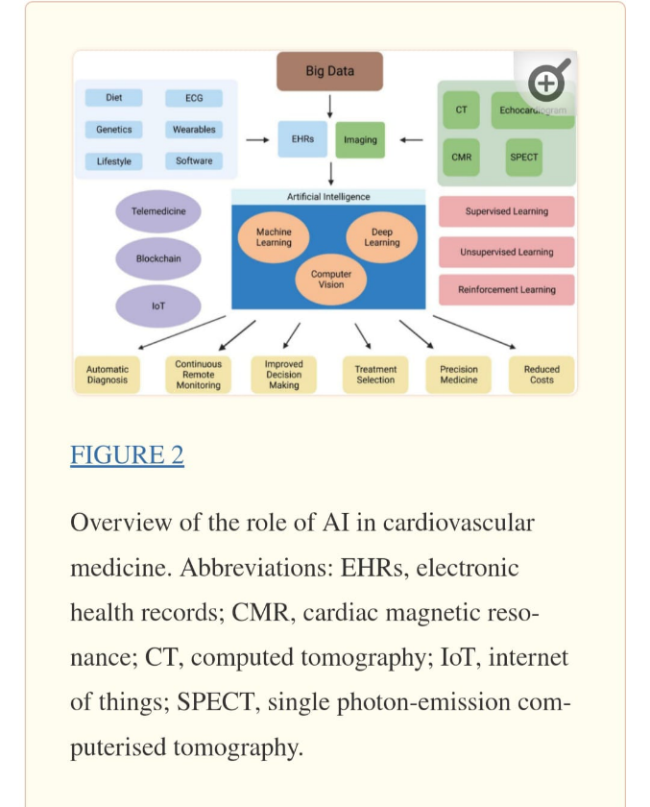

The applications of AI in health care is far reaching that is from scanning radiological images for detection and prediction of early outcomes through Electronic Health Records (EHR).
By using AI in hospitals, it has the potential to reduce human errors through quick way to review health records, imaging claims, processing and test results.
Ophthalmology-Google’s Deep Mind Health Project, demonstrated the diagnosis of eye diseases from retinal scans with high accuracy. AI is used for treating impaired vision like macular holes, age related maculae degeneration, diabetic retinopathy, glaucoma and cataracts. AI has led to development in visual field testing, optical coherence tomography (OCT) and images from back of the eye. Oct picture monitor and diagnose renal illness like macular holes etc. Deep learning methods are used to read OCT pictures. CNN algorithm (VGG16) is used to diagnose macular condition in OCT scans. CNN algorithm has 2 parts: one is an encoder which encodes the essential features of the image in the feature map. This map is flattened into a list of numbers called vector passed to FFNN. Which specifies the likelihood of a patient developing age related macular degeneration. Deep learning algorithm is used for identifying macular edema in OCT images. This method has an accuracy of 0.94 and superior performance in identifying intraretinal fluid in AMD. Deep See Net has precision and accuracy for specialists in detection of pigment abnormalities and drusen characteristics of age-related macular degeneration. Oct is used to treat glaucoma, which automatically measures the thickness of the retinal fiber layer (RNFL) and ganglion cell layer by using automatic AI segmentation technique.
Psychiatry-ML based model is now a days capable of predicting accurately stratifying suicide risk among patients scheduled for an intake visit to an outpatient mental healthcare.
AI is helpful for accelerating clinical trials by improving trial design, optimizing screening and enhancing recruitment workflow. AI models are also helpful for advancing clinical trial data analysis which helps researchers to process huge datasets, detect various patterns, predict the results and propose treatment strategies which is informed by patient data
Challenges for AI in Healthcare:
Many health care organisations are investing huge amount in the use of AI in healthcare for many tasks in spite of many ethical and regulatory issues which may not apply. Few challenges like Data privacy and security, patient safety and accuracy, training algorithms for recognising patterns in medical data, integration of AI with IT systems, in gaining doctors acceptance and trust, and with few regulations and compliance. Data privacy is very important as AI collects patient data in large amounts which may be misused if not handled properly. Security measures must be taken properly to prevent patients data from being exploited for other malicious purposes. AI Systems must be well trained to understand the relationship between different ways of diagnosis and treatments and in providing accurate recommendations of each patient. AI must be linked with IT systems as it helps to understand of how this technology is working.

